Abstraction : Managing Different Media
S. Nisanth , ID = 12576

Code:
Program.cs:

class TuneIn{
public static void Main(){
Song song= new Song();
Movie movie= new Movie();
Podcast podcast= new Podcast();

song.PlayMedia();
song.PauseMedia();
song.StopMedia();

movie.PlayMedia();
movie.PauseMedia();
movie.StopMedia();

podcast.PlayMedia();
podcast.PauseMedia();
podcast.StopMedia();

Media media= new Song();

media.IncreaseVolume();
media.DecreaseVolume();

Console.WriteLine("\nAll methods ave been called.");
}
}

Movie.cs:

class Movie : Media
{
public override void PlayMedia()
{
Console.WriteLine("\nPlaying Movie...");
}

public override void PauseMedia()
{
Console.WriteLine("Pausing Movie...");
}

public override void StopMedia()
{
Console.WriteLine("Stopping Movie...");
}
}

Podcast.cs:

class Podcast : Media
{
public override void PlayMedia()
{
Console.WriteLine("\nPlaying Podcast...");
}

public override void PauseMedia()
{
Console.WriteLine("Pausing Podcast...");
}

public override void StopMedia()
{
Console.WriteLine("Stopping Podcast...");
}
}

Song.cs:

class Song : Media
{
public override void PlayMedia()
{
Console.WriteLine("\nPlaying Song...");
}

public override void PauseMedia()
{
Console.WriteLine("Pausing Song...");
}

public override void StopMedia()
{
Console.WriteLine("Stopping Song...");
}
}

Output:

(Next Page...)
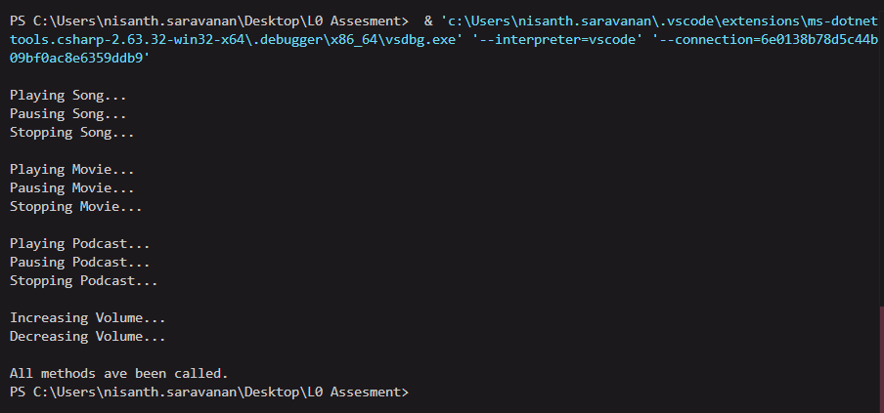

Inheritance - Different Types of Employees
S. Nisanth , ID = 12576

Code:
Employee.cs:

class Employee
{
public int Id { get; set; }
public string Name { get; set; }
public double Salary { get; set; }
public double Bonus = 10.00;

public Employee(int id, string name, double salary)
{
Id = id;
Name = name;
Salary = salary;
}

public Employee()
{
return;
}

public double BonusAmount(List<Employee> employees)
{
Console.WriteLine("\nEnter the ID:");
int id = int.Parse(Console.ReadLine());

Employee employee = employees.FirstOrDefault(e => e.Id == id);
if (employee == null)
{
return 0.00;
}
else
{
return employee.Salary * employee.Bonus * 0.10;
}
}

public void AddEmployee(List<Employee> employees)
{
Console.WriteLine("\nEnter the Employee Details: ");
Console.Write("ID: ");
int id = int.Parse(Console.ReadLine());
Console.Write("Name: ");
string name = Console.ReadLine();
Console.Write("Salary: ");
double salary = double.Parse(Console.ReadLine());

Employee employee = new Employee(id, name, salary);
employees.Add(employee);
}

public virtual void RemoveEmployee(List<Employee> employees)
{
Console.Write("\nEnter the ID to remove: ");
int id = int.Parse(Console.ReadLine());

Employee employeeToRemove = employees.Find(x => x.Id == id);
if (employeeToRemove != null)
{
employees.Remove(employeeToRemove);
Console.WriteLine($"\nThe employee of ID {id} removed successfully.");
}
else
{
Console.WriteLine($"\nThe employee of ID {id} does not exist.");
}
}
}

Manager.cs:

class Manager : Employee
{
public int NumberOfDirectReports { get; set; }

public Manager(int id, string name, double salary, int numberOfDirectReports) : base(id, name, salary)
{
NumberOfDirectReports = numberOfDirectReports;
}

public Manager(){
return;
}

public double BonusAmount(List<Manager> managers)
{
Console.WriteLine("\nEnter the ID:");
int id = int.Parse(Console.ReadLine());

Manager manager = managers.FirstOrDefault(e => e.Id == id);
if (manager == null)
{
return 0.00;
}
else
{
return manager.Salary * 0.10 + manager.NumberOfDirectReports * 100;
}
}

public void AddManager(List<Manager> managers)
{
Console.WriteLine("\nEnter the Manager Details: ");
Console.Write("ID: ");
int id = int.Parse(Console.ReadLine());
Console.Write("Name: ");
string name = Console.ReadLine();
Console.Write("Salary: ");
double salary = double.Parse(Console.ReadLine());
Console.Write("Number of direct reports: ");
int numberOfDirectReports = int.Parse(Console.ReadLine());

Manager manager = new Manager(id, name, salary, numberOfDirectReports);
managers.Add(manager);
}

public virtual void RemoveManager(List<Manager> managers)
{
Console.Write("\nEnter the ID to remove: ");
int id = int.Parse(Console.ReadLine());

Manager ManagerToRemove = managers.Find(x => x.Id == id);
if (ManagerToRemove != null)
{
managers.Remove(ManagerToRemove);
Console.WriteLine($"\nThe Manager of ID {id} removed successfully.");
}
else
{
Console.WriteLine($"\nThe Manager of ID {id} does not exist.");
}
}
}

Contractor.cs:

class Contractor : Employee
{
public double HourlyRate { get; set; }
public double HoursWorked { get; set; }

public Contractor(int id, string name, double salary, double hourlyRate, double hoursWorked) : base(id, name, salary)
{
HourlyRate = hourlyRate;
HoursWorked = hoursWorked;
}

public Contractor(){
return;
}

public double BonusAmount(List<Contractor> contractors)
{
Console.WriteLine("\nEnter the ID:");
int id = int.Parse(Console.ReadLine());

Contractor contractor = contractors.FirstOrDefault(e => e.Id == id);
if (contractor == null)
{
return 0.00;
}
else
{
return contractor.HourlyRate * contractor.HoursWorked * 0.05;
}
}

public void AddContractor(List<Contractor> contractors)
{
Console.WriteLine("\nEnter the Contractor Details: ");
Console.Write("ID: ");
int id = int.Parse(Console.ReadLine());
Console.Write("Name: ");
string name = Console.ReadLine();
Console.Write("Salary: ");
double salary = double.Parse(Console.ReadLine());
Console.Write("Hourly Rate: ");
double hourlyRate = double.Parse(Console.ReadLine());
Console.Write("Hours Worked: ");
double hoursWorked = double.Parse(Console.ReadLine());

Contractor contractor= new Contractor(id, name, salary, hourlyRate, hoursWorked);
contractors.Add(contractor);
}

public virtual void RemoveContractor(List<Contractor> Contractors)
{
Console.Write("\nEnter the ID to remove: ");
int id = int.Parse(Console.ReadLine());

Contractor ContractorToRemove = Contractors.Find(x => x.Id == id);
if (ContractorToRemove != null)
{
Contractors.Remove(ContractorToRemove);
Console.WriteLine($"\nThe Contractor of ID {id} removed successfully.");
}
else
{
Console.WriteLine($"\nThe Contractor of ID {id} does not exist.");
}
}
}

Program.cs:

class Company
{
public List<Employee> employees = new List<Employee>();
public List<Manager> managers = new List<Manager>();
public List<Contractor> contractors = new List<Contractor>();

public static void Main()
{
Company company = new Company();
Employee employee = new Employee();
Manager manager = new Manager();
Contractor contractor = new Contractor();

checkpoint1:
Console.WriteLine("\nEmployee Record System: ");
Console.WriteLine("1. Add Employee.");
Console.WriteLine("2. Add Manager.");
Console.WriteLine("3. Add Contractor.");
Console.WriteLine("4. Remove Employee.");
Console.WriteLine("5. Calculate Bonus.");
Console.WriteLine("0. Exit.");

Console.WriteLine("\nEnter your choice: ");
int choice1 = int.Parse(Console.ReadLine());

switch (choice1)
{
default:
{
Console.WriteLine("\nINVALID CHOICE! TRY AGAIN!");
goto checkpoint1;
}

case 0:
{
Console.WriteLine("\nLOGGING OUT...");
return;
}

case 1:
{
employee.AddEmployee(company.employees);
goto checkpoint1;
}

case 2:
{
manager.AddManager(company.managers);
goto checkpoint1;
}

case 3:
{
contractor.AddContractor(company.contractors);
goto checkpoint1;
}

case 4:
{
goto removal;
}

case 5:
{
goto bonuses;
}
}

removal:
Console.WriteLine("\nChoose what to remove:");
Console.WriteLine("1. Employee.");
Console.WriteLine("2. Manager.");
Console.WriteLine("3. Contractor.");
Console.WriteLine("0. Back.");

Console.WriteLine("\nEnter your choice: ");
int choice2 = int.Parse(Console.ReadLine());

switch (choice2)
{
default:
{
Console.WriteLine("\nINVALID CHOICE! TRY AGAIN!");
goto removal;
}

case 0:
{
goto checkpoint1;
}

case 1:
{
employee.RemoveEmployee(company.employees);
goto checkpoint1;
}

case 2:
{
manager.RemoveManager(company.managers);
goto checkpoint1;
}

case 3:
{
contractor.RemoveContractor(company.contractors);
goto checkpoint1;
}
}

bonuses:

Console.WriteLine("\nChoose for whom to calculate:");
Console.WriteLine("1. Employee.");
Console.WriteLine("2. Manager.");
Console.WriteLine("3. Contractor.");
Console.WriteLine("0. Back.");

Console.WriteLine("\nEnter your choice: ");
int choice3 = int.Parse(Console.ReadLine());

switch (choice3)
{
default:
{
Console.WriteLine("\nINVALID CHOICE! TRY AGAIN!");
goto bonuses;
}

case 0:
{
goto checkpoint1;
}

case 1:
{
Console.WriteLine($"The bonus of the selected regular employee is {employee.BonusAmount(company.employees)}.");
goto checkpoint1;
}

case 2:
{
Console.WriteLine($"The bonus of the selected manager is {manager.BonusAmount(company.managers)}");
goto checkpoint1;
}

case 3:
{
Console.WriteLine($"The bonus of the selected contractor is {contractor.BonusAmount(company.contractors)}");
goto checkpoint1;
}
}

}
}

Output:
